[root@vm-vol-nag4-prod ~]# vim -R /var/spool/cron/root
...
# Follow script informs employee of the first line of technical support via separate emails about every troubled services. Then they will process every of these emails and create service desk case to resolve it.
02 23,10,17 * * * /opt/TCS/scripts/nagios/nagios_find_services_with_critical_state_more_then_8_hours_and_send_separate_emails_to_servicedesk.sh
# Follow script is used exactly for debug purposes.
# 03 23,10,17 * * * /opt/TCS/scripts/nagios/nagios_find_services_with_critical_state_more_then_8_hours_and_send_separate_emails_to_servicedesk.debug.sh
# Follow script is used to send me email to be sure that engine of this scripts works properly. It send one email, that has info about all services in inapropriate state.
04 23,10,17 * * * /opt/TCS/scripts/nagios/email_notification_for_nagios_find_services_with_critical_state_more_then_8_hours_and_have_no_downtime_acknowledge_comment.sh
...

[root@vm-vol-nag4-prod ~]# ls -Alh /opt/TCS/scripts/nagios/
total 124K
-rwxr-xr-x 1 root root 508 Oct 30 2017 cards24x7_subscription.sh
-rwxr-xr-x 1 root root 317 Apr 25 2016 email_notification_for_nagios_find_greenplum_hardware_check_service_with_critical_state.sh
-rwxr-xr-x 1 root root 314 Apr 25 2016 email_notification_for_nagios_find_hadoop_hardware_check_service_with_critical_state.sh
-rwxr-xr-x 1 root root 341 Apr 25 2016 email_notification_for_nagios_find_services_with_critical_state_more_then_10_days.sh
-rwxr-xr-x 1 root root 508 May 27 2016 email_notification_for_nagios_find_services_with_critical_state_more_then_8_hours_and_have_no_downtime_acknowledge_comment.sh
-rwxr-xr-x 1 root root 341 Apr 25 2016 email_notification_for_nagios_find_services_with_critical_state_more_then_8_hours.sh
-rwxr-xr-x 1 root root 519 Apr 28 2016 email_notification_for_nagios_find_services_with_manually_turned_off_notification_via_web_gui_and_have_no_downtime_acknowledge_comment.sh
drwxr-xr-x 8 root root 4.0K Oct 30 2017 .git
-rwxr-xr-x 1 root root 5.8K Jun 3 2016 nagios_find_greenplum_hardware_check_service_with_critical_state.sh
-rwxr-xr-x 1 root root 5.6K Jun 3 2016 nagios_find_hadoop_hardware_check_service_with_critical_state.sh
-rwxr-xr-x 1 root root 4.3K Apr 25 2016 nagios_find_services_with_critical_state_more_then_10_days.sh
-rwxr-xr-x 1 root root 4.8K Sep 29 2016 nagios_find_services_with_critical_state_more_then_8_hours_and_have_no_downtime_acknowledge_comment.sh
-rwxr-xr-x 1 root root 4.8K Sep 29 2016 nagios_find_services_with_critical_state_more_then_8_hours_and_send_separate_emails.sh
-rwxr-xr-x 1 root root 6.6K Sep 28 2016 nagios_find_services_with_critical_state_more_then_8_hours_and_send_separate_emails_to_servicedesk.debug.sh
-rwxr-xr-x 1 root root 5.2K Dec 27 2016 nagios_find_services_with_critical_state_more_then_8_hours_and_send_separate_emails_to_servicedesk.sh
-rwxr-xr-x 1 root root 4.6K Apr 25 2016 nagios_find_services_with_critical_state_more_then_8_hours.sh
-rwxr-xr-x 1 root root 3.8K Apr 26 2016 nagios_find_services_with_manually_turned_off_notification_via_web_gui_and_have_no_downtime_acknowledge_comment.sh
-rwxr-xr-x 1 root root 3.2K Apr 25 2016 nagios_print_date_when_service_has_critical_state.sh
-rwxr-xr-x 1 root root 3.5K Nov 7 2016 nagios_restore_not_persistant_comments.sh
-rwxr-xr-x 1 root root 3.9K Apr 5 2017 nagios_save_not_persistant_comments.sh
-rwxr-xr-x 1 root root 497 Apr 25 2016 nagstatus.sh
-rwxr-xr-x 1 root root 1.7K Dec 7 2017 pwd-expire-users.sh
-rw-r--r-- 1 root root 220 Apr 25 2016 README
[root@vm-vol-nag4-prod ~]#

[root@vm-vol-nag4-prod nagios]# cat nagios_find_services_with_critical_state_more_then_10_days.sh
#!/bin/bash

# Here is defenition of days.
# If some service has his critical state more, then these last days - we conclude to print information about it.
let days=10

let index=0

while IFS=';' read -a array_for_read_data
do
#echo "array_for_read_data[0] = ${array_for_read_data[0]}"
#echo "array_for_read_data[1] = ${array_for_read_data[1]}"

array_first_argument[${index}]="${array_for_read_data[0]}"
array_second_argument[${index}]="${array_for_read_data[1]}"

#echo "array_first_argument[${index}] = ${array_first_argument[${index}]}"
#echo "array_second_argument[${index}] = ${array_second_argument[${index}]}"

((index++))

#echo "index = $index"
#echo '${!array_first_argument[*]}' = "${!array_first_argument[*]}"
#echo '${#array_first_argument[*]}' = "${#array_first_argument[*]}"
#echo '${array_first_argument[@]}' = "${array_first_argument[@]}"
done < <( echo -e "GET services\nFilter: state = 2\nFilter: notifications_enabled = 0\nColumns: host_name description" | /usr/local/bin/unixcat /usr/local/nagios/var/rw/live )

#echo
#echo '${!array_first_argument[*]}' = "${!array_first_argument[*]}"
#echo '${#array_first_argument[*]}' = "${#array_first_argument[*]}"
#echo '${array_first_argument[@]}' = "${array_first_argument[@]}"

for (( count=0 ; count < ${index} ; count++ ))
do
#echo "array_first_argument[${count}] = ${array_first_argument[${count}]}"
#echo "array_second_argument[${count}] = ${array_second_argument[${count}]}"
#echo "count = ${count}"

# Define amount of hours, when we will search service, that have critical state.
# We should find the latest critical state duration of service from list, if service state has several critical states during previously defined time interval.
#let hours=$( expr ${days} \* 24 )
# Here I have increaced time in twice. It's not necessary do that. It was done only to get more information about tested services.
let hours=$( expr ${days} \* 24 \* 2 )
#echo -e "GET statehist\nFilter: host_name = ${array_first_argument[${count}]}\nFilter: service_description = ${array_second_argument[${count}]}\nFilter: time >= $(expr $(date "+%s") - ${hours} \* 60 \* 60)\nColumns: duration_critical" | /usr/local/bin/unixcat /usr/local/nagios/var/rw/live

while read variable_to_read_duration_of_critical_state
do
:
#echo '${variable_to_read_duration_of_critical_state}' = "${variable_to_read_duration_of_critical_state}"
variable_duration_critical_state=${variable_to_read_duration_of_critical_state}
:
done < <( echo -e "GET statehist\nFilter: host_name = ${array_first_argument[${count}]}\nFilter: service_description = ${array_second_argument[${count}]}\nFilter: time >= $(expr $(date "+%s") - ${hours} \* 60 \* 60)\nColumns: duration_critical" | /usr/local/bin/unixcat /usr/local/nagios/var/rw/live )

#echo '${variable_duration_critical_state}' = "${variable_duration_critical_state}"
array_duration_last_critical_state[${count}]="${variable_duration_critical_state}"

done

#echo
#echo '${!array_duration_last_critical_state[*]}' = "${!array_duration_last_critical_state[*]}"
#echo '${#array_duration_last_critical_state[*]}' = "${#array_duration_last_critical_state[*]}"
#echo '${array_duration_last_critical_state[@]}' = "${array_duration_last_critical_state[@]}"

# Critical state duration in days.
let defined_critical_state_duration=${days}
title_already_printed="false"
for (( count=0 ; count < ${index} ; count++ ))
do

if [ $(bc <<< "$(bc <<< "scale=2;${array_duration_last_critical_state[${count}]} / 60 / 60 / 24") >= ${defined_critical_state_duration}") -eq 1 ]
then
if [ "${title_already_printed}" = "false" ] ; then echo "Critical state duration for services without notification is equal or even more then ${defined_critical_state_duration} days." ; title_already_printed="true" ; fi
echo
echo "Host: ${array_first_argument[${count}]}"
echo "Service: ${array_second_argument[${count}]}"
echo "Duration: $(bc <<< "scale=2;${array_duration_last_critical_state[${count}]} / 60 / 60 / 24") days"
fi
#echo "$(bc <<< "scale=2;${array_duration_last_critical_state[${count}]} / 60 / 60 / 24")" '>=' "${defined_critical_state_duration}" "--> if $(bc <<< "$(bc <<< "scale=2;${array_duration_last_critical_state[${count}]} / 60 / 60 / 24") >= ${defined_critical_state_duration}") -eq 1"

done

[root@vm-vol-nag4-prod nagios]#

[root@vm-vol-nag4-prod nagios]# cat nagios_find_services_with_manually_turned_off_notification_via_web_gui_and_have_no_downtime_acknowledge_comment.sh
#!/bin/bash

let index=0

# Here is finding hosts, that have turned off notification via nagios web-GUI.
# Simultaneously these hosts have no downtime, acknowledge, comment.
# Information about this hosts are placing into one array.
# Array contain host name.
while IFS=';' read -a array_for_read_data
do
#echo "array_for_read_data[0] = ${array_for_read_data[0]}"

array_first_argument[${index}]="${array_for_read_data[0]}"

#echo "array_first_argument[${index}] = ${array_first_argument[${index}]}"

((index++))

#echo "index = $index"
#echo '${!array_first_argument[*]}' = "${!array_first_argument[*]}"
#echo '${#array_first_argument[*]}' = "${#array_first_argument[*]}"
#echo '${array_first_argument[@]}' = "${array_first_argument[@]}"

# Here is finding hosts, that have turned off notification via nagios web-GUI.
# Simultaneously these hosts have no downtime, acknowledge, comment.
done < <( echo -e "GET hosts\nColumns: host_name\nFilter: modified_attributes ~ notifications_enabled\nFilter: notifications_enabled = 0\nFilter: acknowledged = 0\nFilter: scheduled_downtime_depth = 0\nFilter: comments =\n" | /usr/local/bin/unixcat /usr/local/nagios/var/rw/live )

#echo
#echo '${!array_first_argument[*]}' = "${!array_first_argument[*]}"
#echo '${#array_first_argument[*]}' = "${#array_first_argument[*]}"
#echo '${array_first_argument[@]}' = "${array_first_argument[@]}"

title_already_printed="false"
for (( count=0 ; count < ${index} ; count++ ))
do

if [ "${title_already_printed}" = "false" ] ; then echo "List of hosts with probably manually turned off notification via nagios web-GUI." ; title_already_printed="true" ; fi
echo
echo "Host: ${array_first_argument[${count}]}"

done

if [ ${index} -gt 0 ] ; then echo ; fi

let index=0

# Here is finding services, that have turned off notification via nagios web-GUI.
# Simultaneously these services have no downtime, acknowledge, comment.
# Information about this services are placing into two arrays.
# Arrays contain host name, description of service.
while IFS=';' read -a array_for_read_data
do
#echo "array_for_read_data[0] = ${array_for_read_data[0]}"
#echo "array_for_read_data[1] = ${array_for_read_data[1]}"

array_first_argument[${index}]="${array_for_read_data[0]}"
array_second_argument[${index}]="${array_for_read_data[1]}"

#echo "array_first_argument[${index}] = ${array_first_argument[${index}]}"
#echo "array_second_argument[${index}] = ${array_second_argument[${index}]}"

((index++))

#echo "index = $index"
#echo '${!array_first_argument[*]}' = "${!array_first_argument[*]}"
#echo '${#array_first_argument[*]}' = "${#array_first_argument[*]}"
#echo '${array_first_argument[@]}' = "${array_first_argument[@]}"

# Here finding services, that have turned off notification via nagios web-GUI.
# Simultaneously these services have no downtime, acknowledge, comment.
done < <( echo -e "GET services\nColumns: host_name description\nFilter: modified_attributes ~ notifications_enabled\nFilter: notifications_enabled = 0\nFilter: acknowledged = 0\nFilter: scheduled_downtime_depth = 0\nFilter: comments =\n" | /usr/local/bin/unixcat /usr/local/nagios/var/rw/live )

#echo
#echo '${!array_first_argument[*]}' = "${!array_first_argument[*]}"
#echo '${#array_first_argument[*]}' = "${#array_first_argument[*]}"
#echo '${array_first_argument[@]}' = "${array_first_argument[@]}"
#echo '${array_second_argument[@]}' = "${array_second_argument[@]}"

title_already_printed="false"
for (( count=0 ; count < ${index} ; count++ ))
do

if [ "${title_already_printed}" = "false" ] ; then echo "List of services with probably manually turned off notification via nagios web-GUI." ; title_already_printed="true" ; fi
echo
echo "Host: ${array_first_argument[${count}]}"
echo "Service: ${array_second_argument[${count}]}"

done

[root@vm-vol-nag4-prod nagios]#

http://www.naemon.org/documentation/usersguide/livestatus.html

#
# https://checkmk.com/cms_livestatus.html
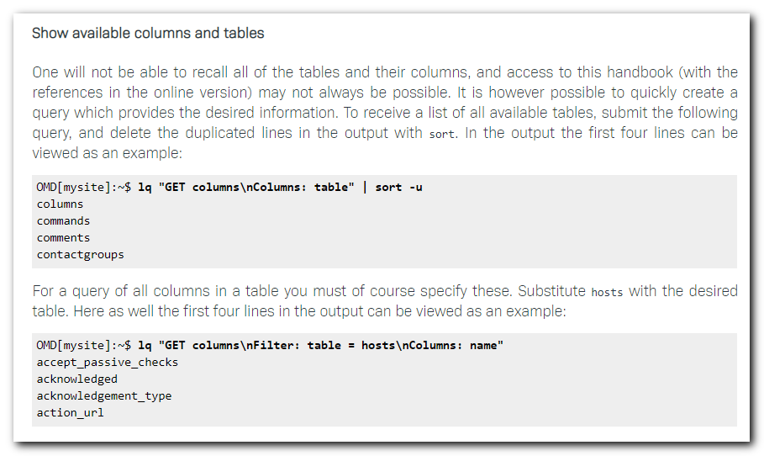

[root@vm-vol-nag4-prod nagios]# echo -e "GET columns\nColumns: table" | /usr/local/bin/unixcat /usr/local/nagios/var/rw/live | sort -u
columns
commands
comments
contactgroups
contacts
downtimes
hostgroups
hosts
hostsbygroup
log
servicegroups
services
servicesbygroup
servicesbyhostgroup
statehist
status
timeperiods
[root@vm-vol-nag4-prod nagios]#

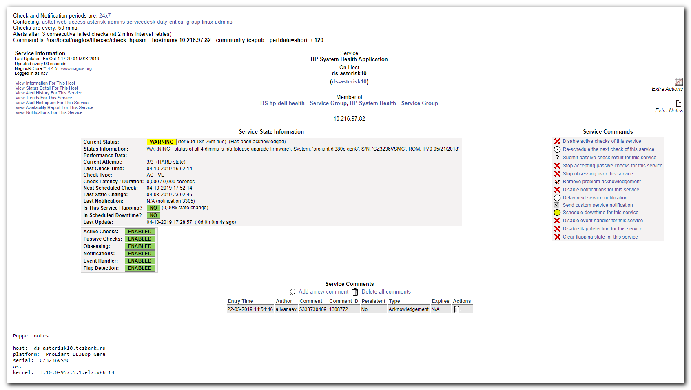

http://www.naemon.org/documentation/usersguide/livestatus.html#timeperiods
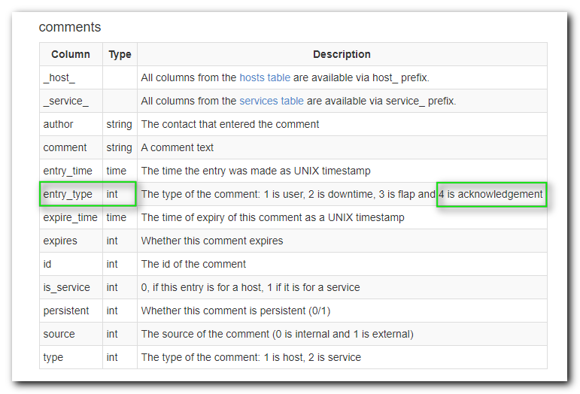

[root@vm-vol-nag4-prod nagios]# echo -e "GET comments\nColumns: entry_time comment\nFilter: entry_type = 4\n" | /usr/local/bin/unixcat /usr/local/nagios/var/rw/live
1457706673;acknowledge problem
1461081840;Чинится
1469191676;Снова отрицательный баланс, и снова доступ в интернет приостановлен.
1488202802;Dell support id 944477813
1498858212;сд 497182, замена батареи планируется 3.07.2017
1508508539;fixed
1558526086;5338730469
1563465160;не используется
1565358677;nice_dw имеет 18% свободного места и удаление записей в базе продолжается. Shrink будет выполнен по завершению удаления устаревших данных
1566536396;По требованию Дергунова Владислава
1566899553;open case
1569489380;SD3220214
1569489433;SD3220214
1570193424;998984395
[root@vm-vol-nag4-prod nagios]#

[root@vm-vol-nag4-prod nagios]# let days=1 ; let hours=$( expr ${days} \* 24 ) ; echo -e "GET comments\nFilter: entry_type = 4\nFilter: entry_time >= $(expr $(date "+%s") - ${hours} \* 60 \* 60)\nColumns: entry_time comment" | /usr/local/bin/unixcat /usr/local/nagios/var/rw/live
1570193424;998984395
[root@vm-vol-nag4-prod nagios]# let days=1 ; let hours=$( expr ${days} \* 24 ) ; echo -e "GET comments\nFilter: entry_type = 4\nFilter: entry_time <= $(expr $(date "+%s") - ${hours} \* 60 \* 60)\nColumns: entry_time comment" | /usr/local/bin/unixcat /usr/local/nagios/var/rw/live
1457706673;acknowledge problem
1461081840;Чинится
1469191676;Снова отрицательный баланс, и снова доступ в интернет приостановлен.
1488202802;Dell support id 944477813
1498858212;сд 497182, замена батареи планируется 3.07.2017
1508508539;fixed
1558526086;5338730469
1563465160;не используется
1565358677;nice_dw имеет 18% свободного места и удаление записей в базе продолжается. Shrink будет выполнен по завершению удаления устаревших данных
1566536396;По требованию Дергунова Владислава
1566899553;open case
1569489380;SD3220214
1569489433;SD3220214
[root@vm-vol-nag4-prod nagios]#

[root@vm-vol-nag4-prod nagios]# let days=1 ; let hours=$( expr ${days} \* 24 ) ; echo $hours
24
[root@vm-vol-nag4-prod nagios]#
[root@vm-vol-nag4-prod nagios]# let days=1 ; let hours=$( expr ${days} \* 24 ) ; echo $hours ; echo "$(expr $(date "+%s") - ${hours} \* 60 \* 60)"
24
1570440455
[root@vm-vol-nag4-prod nagios]#

#
# Here are acknowleges made 1 day ago or earlier.
#
[root@vm-vol-nag4-prod nagios]# let days=1 ; let hours=$( expr ${days} \* 24 ) ; echo -e "GET comments\nFilter: entry_type = 4\nFilter: entry_time <= $(expr $(date "+%s") - ${hours} \* 60 \* 60)\nColumns: entry_time comment" | /usr/local/bin/unixcat /usr/local/nagios/var/rw/live
1457706673;acknowledge problem
1461081840;Чинится
1469191676;Снова отрицательный баланс, и снова доступ в интернет приостановлен.
1488202802;Dell support id 944477813
1498858212;сд 497182, замена батареи планируется 3.07.2017
1508508539;fixed
1558526086;5338730469
1563465160;не используется
1565358677;nice_dw имеет 18% свободного места и удаление записей в базе продолжается. Shrink будет выполнен по завершению удаления устаревших данных
1566536396;По требованию Дергунова Владислава
1566899553;open case
1569489380;SD3220214
1569489433;SD3220214
1570193424;998984395
1570429806;5342072490
[root@vm-vol-nag4-prod nagios]#

#
# Here I can print info about service and host - it were taken from Service column and Host column - I made it with service_ prefix and host_ prefix and suffix was used from appropriate table - Service or Host.
#
[root@vm-vol-nag4-prod nagios]# let days=1 ; let hours=$( expr ${days} \* 24 ) ; echo -e "GET comments\nFilter: entry_type = 4\nFilter: entry_time <= $(expr $(date "+%s") - ${hours} \* 60 \* 60)\nColumns: entry_time comment host_name service_description" | /usr/local/bin/unixcat /usr/local/nagios/var/rw/live
1457706673;acknowledge problem;ds-gate-fa0-0;
1461081840;Чинится;vm-esb-tst01;Check Updates
1469191676;Снова отрицательный баланс, и снова доступ в интернет приостановлен.;hq-vol-proxy01;LTE access
1488202802;Dell support id 944477813;ds-splunk-nidx01;Server Health
1498858212;сд 497182, замена батареи планируется 3.07.2017;m1-sasetl01p;HP System Health Application
1508508539;fixed;ds-asterisk05;Calls transferring
1558526086;5338730469;ds-asterisk10;HP System Health Application
1563465160;не используется;m1-sql01;Service: SQL Server Analysis - MSSQLSERVER
1565358677;nice_dw имеет 18% свободного места и удаление записей в базе продолжается. Shrink будет выполнен по завершению удаления устаревших данных;ds-nice-db01;Drive D: Space
1566536396;По требованию Дергунова Владислава;vm-nice-wfm;Memory Usage
1566899553;open case;m1-gp-prod-sdw54;Server Health
1569489380;SD3220214;m1-db31-dr;Partition All local
1569489433;SD3220214;ds-db31-prod1;Partition All local
1570193424;998984395;m1-gp-prod-sdw47;Server Health
1570429806;5342072490;m1-hadoop-wk06t;HP System Health Application
[root@vm-vol-nag4-prod nagios]#

#
# Here are acknowleges made earlier, than 1 day.
#
[root@vm-vol-nag4-prod nagios]# let days=1 ; let hours=$( expr ${days} \* 24 ) ; echo -e "GET comments\nFilter: entry_type = 4\nFilter: entry_time > $(expr $(date "+%s") - ${hours} \* 60 \* 60)\nColumns: entry_time comment" | /usr/local/bin/unixcat /usr/local/nagios/var/rw/live
1570518898;5342027629
1570518899;5342027629
[root@vm-vol-nag4-prod nagios]# date -d@1570518898 +%Y%m%d-%H%M
20191008-1014
[root@vm-vol-nag4-prod nagios]# date -d@1570518899 +%Y%m%d-%H%M
20191008-1014
[root@vm-vol-nag4-prod nagios]#

#
# There are no acknowleged hosts.
#
[root@vm-vol-nag4-prod nagios]# echo -e "GET hosts\nColumns: host_name\nFilter: acknowledged = 1\n" | /usr/local/bin/unixcat /usr/local/nagios/var/rw/live
[root@vm-vol-nag4-prod nagios]#

#
# There are several services wich have acknoledge set.
#
[root@vm-vol-nag4-prod nagios]# echo -e "GET services\nColumns: host_name description\nFilter: acknowledged = 1\n" | /usr/local/bin/unixcat /usr/local/nagios/var/rw/live
ds-asterisk10;HP System Health Application
ds-db31-prod1;Partition All local
ds-nice-db01;Drive D: Space
ekb-mvno-kvm05p;Server Health ilo5
m1-db31-dr;Partition All local
m1-gp-prod-sdw47;Server Health
m1-gp-prod-sdw54;Server Health
m1-hadoop-wk06t;HP System Health Application
m1-sql01;Service: SQL Server Analysis - MSSQLSERVER
vm-nice-wfm;Memory Usage
[root@vm-vol-nag4-prod nagios]#

[root@vm-vol-nag4-prod nagios]# let days=1 ; let hours=$( expr ${days} \* 24 \* 2 ) ; echo -e "GET statehist\nFilter: host_name = ds-asterisk10\nFilter: service_description = HP System Health Application\nColumns:" | /usr/local/bin/unixcat /usr/local/nagios/var/rw/live
current_host_accept_passive_checks;current_host_acknowledged;current_host_acknowledgement_type;current_host_action_url;current_host_action_url_expanded;current_host_active_checks_enabled;current_host_address;current_host_alias;current_host_check_command;current_host_check_command_expanded;current_host_check_flapping_recovery_notification;current_host_check_freshness;current_host_check_interval;current_host_check_options;current_host_check_period;current_host_check_type;current_host_checks_enabled;current_host_childs;current_host_comments;current_host_comments_with_extra_info;current_host_comments_with_info;current_host_contact_groups;current_host_contacts;current_host_current_attempt;current_host_current_notification_number;current_host_custom_variable_names;current_host_custom_variable_values;current_host_custom_variables;current_host_display_name;current_host_downtimes;current_host_downtimes_with_info;current_host_event_handler;current_host_event_handler_enabled;current_host_execution_time;current_host_filename;current_host_first_notification_delay;current_host_flap_detection_enabled;current_host_groups;current_host_hard_state;current_host_has_been_checked;current_host_high_flap_threshold;current_host_icon_image;current_host_icon_image_alt;current_host_icon_image_expanded;current_host_in_check_period;current_host_in_notification_period;current_host_in_service_period;current_host_initial_state;current_host_is_executing;current_host_is_flapping;current_host_last_check;current_host_last_hard_state;current_host_last_hard_state_change;current_host_last_notification;current_host_last_state;current_host_last_state_change;current_host_last_time_down;current_host_last_time_unreachable;current_host_last_time_up;current_host_latency;current_host_long_plugin_output;current_host_low_flap_threshold;current_host_max_check_attempts;current_host_metrics;current_host_mk_inventory;current_host_mk_inventory_gz;current_host_mk_inventory_last;current_host_modified_attributes;current_host_modified_attributes_list;current_host_name;current_host_next_check;current_host_next_notification;current_host_no_more_notifications;current_host_notes;current_host_notes_expanded;current_host_notes_url;current_host_notes_url_expanded;current_host_notification_interval;current_host_notification_period;current_host_notifications_enabled;current_host_num_services;current_host_num_services_crit;current_host_num_services_hard_crit;current_host_num_services_hard_ok;current_host_num_services_hard_unknown;current_host_num_services_hard_warn;current_host_num_services_ok;current_host_num_services_pending;current_host_num_services_unknown;current_host_num_services_warn;current_host_obsess_over_host;current_host_parents;current_host_pending_flex_downtime;current_host_percent_state_change;current_host_perf_data;current_host_plugin_output;current_host_pnpgraph_present;current_host_process_performance_data;current_host_retry_interval;current_host_scheduled_downtime_depth;current_host_service_period;current_host_services;current_host_services_with_fullstate;current_host_services_with_info;current_host_services_with_state;current_host_staleness;current_host_state;current_host_state_type;current_host_statusmap_image;current_host_total_services;current_host_worst_service_hard_state;current_host_worst_service_state;current_host_x_3d;current_host_y_3d;current_host_z_3d;current_service_accept_passive_checks;current_service_acknowledged;current_service_acknowledgement_type;current_service_action_url;current_service_action_url_expanded;current_service_active_checks_enabled;current_service_cache_interval;current_service_cached_at;current_service_check_command;current_service_check_command_expanded;current_service_check_freshness;current_service_check_interval;current_service_check_options;current_service_check_period;current_service_check_type;current_service_checks_enabled;current_service_comments;current_service_comments_with_extra_info;current_service_comments_with_info;current_service_contact_groups;current_service_contacts;current_service_current_attempt;current_service_current_notification_number;current_service_custom_variable_names;current_service_custom_variable_values;current_service_custom_variables;current_service_description;current_service_display_name;current_service_downtimes;current_service_downtimes_with_info;current_service_event_handler;current_service_event_handler_enabled;current_service_execution_time;current_service_first_notification_delay;current_service_flap_detection_enabled;current_service_groups;current_service_has_been_checked;current_service_high_flap_threshold;current_service_icon_image;current_service_icon_image_alt;current_service_icon_image_expanded;current_service_in_check_period;current_service_in_notification_period;current_service_in_service_period;current_service_initial_state;current_service_is_executing;current_service_is_flapping;current_service_last_check;current_service_last_hard_state;current_service_last_hard_state_change;current_service_last_notification;current_service_last_state;current_service_last_state_change;current_service_last_time_critical;current_service_last_time_ok;current_service_last_time_unknown;current_service_last_time_warning;current_service_latency;current_service_long_plugin_output;current_service_low_flap_threshold;current_service_max_check_attempts;current_service_metrics;current_service_modified_attributes;current_service_modified_attributes_list;current_service_next_check;current_service_next_notification;current_service_no_more_notifications;current_service_notes;current_service_notes_expanded;current_service_notes_url;current_service_notes_url_expanded;current_service_notification_interval;current_service_notification_period;current_service_notifications_enabled;current_service_obsess_over_service;current_service_percent_state_change;current_service_perf_data;current_service_plugin_output;current_service_pnpgraph_present;current_service_process_performance_data;current_service_retry_interval;current_service_scheduled_downtime_depth;current_service_service_period;current_service_staleness;current_service_state;current_service_state_type;debug_info;duration;duration_critical;duration_ok;duration_part;duration_part_critical;duration_part_ok;duration_part_unknown;duration_part_unmonitored;duration_part_warning;duration_unknown;duration_unmonitored;duration_warning;from;host_down;host_name;in_downtime;in_host_downtime;in_notification_period;in_service_period;is_flapping;lineno;log_output;notification_period;service_description;service_period;state;time;until
[root@vm-vol-nag4-prod nagios]#

https://assets.nagios.com/downloads/nagioscore/docs/nagioscore/3/en/extcommands.html

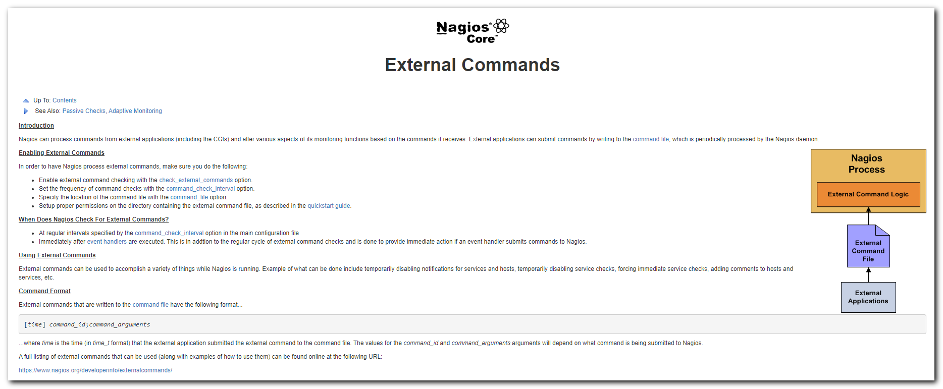

https://assets.nagios.com/downloads/nagioscore/docs/externalcmds/

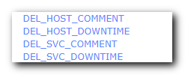


https://assets.nagios.com/downloads/nagioscore/docs/externalcmds/cmdinfo.php?command_id=3
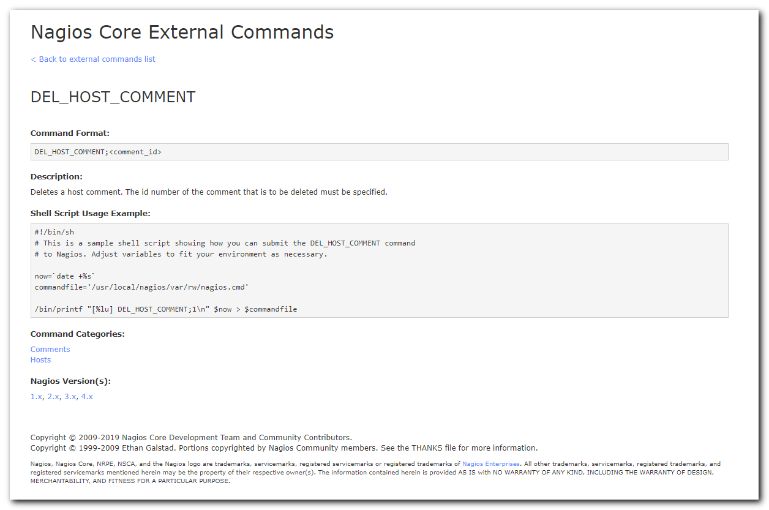

https://assets.nagios.com/downloads/nagioscore/docs/externalcmds/cmdinfo.php?command_id=125
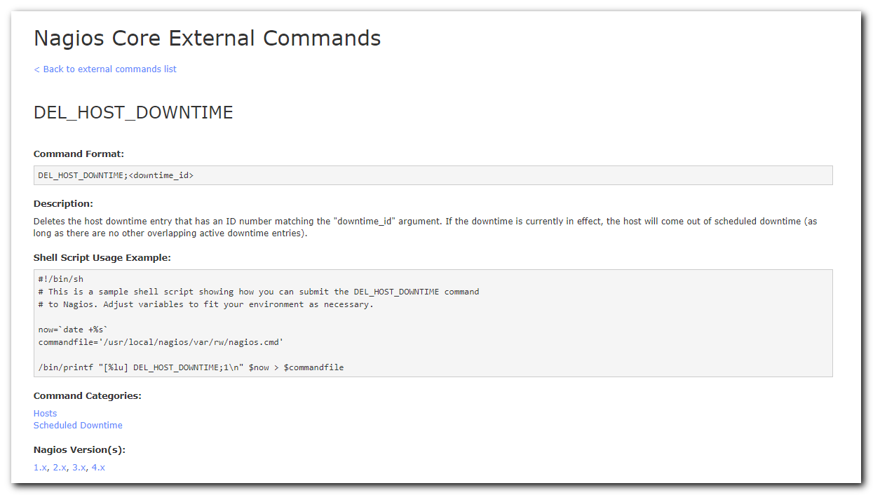

https://assets.nagios.com/downloads/nagioscore/docs/externalcmds/cmdinfo.php?command_id=4
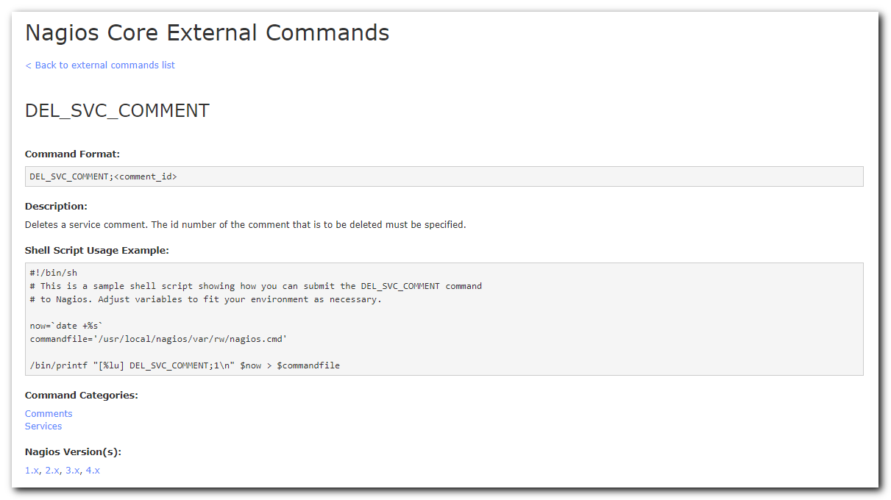

https://assets.nagios.com/downloads/nagioscore/docs/externalcmds/cmdinfo.php?command_id=126
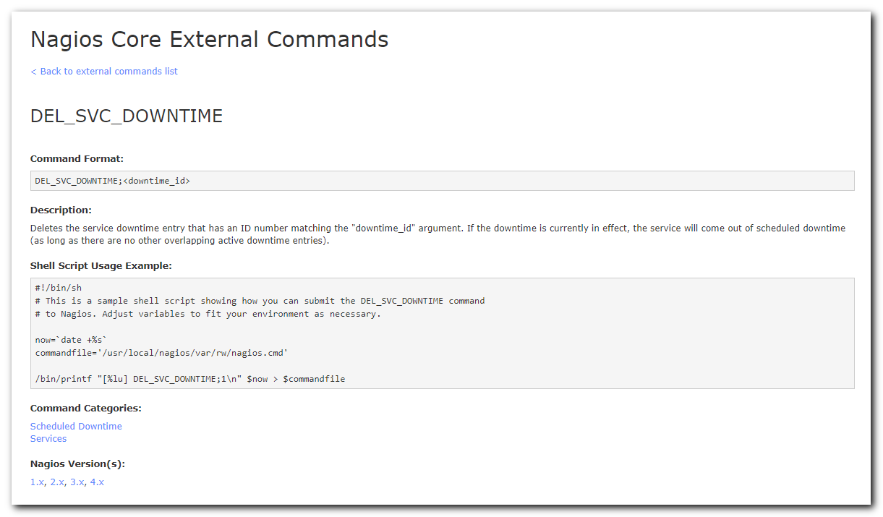

https://assets.nagios.com/downloads/nagioscore/docs/externalcmds/cmdinfo.php?command_id=116
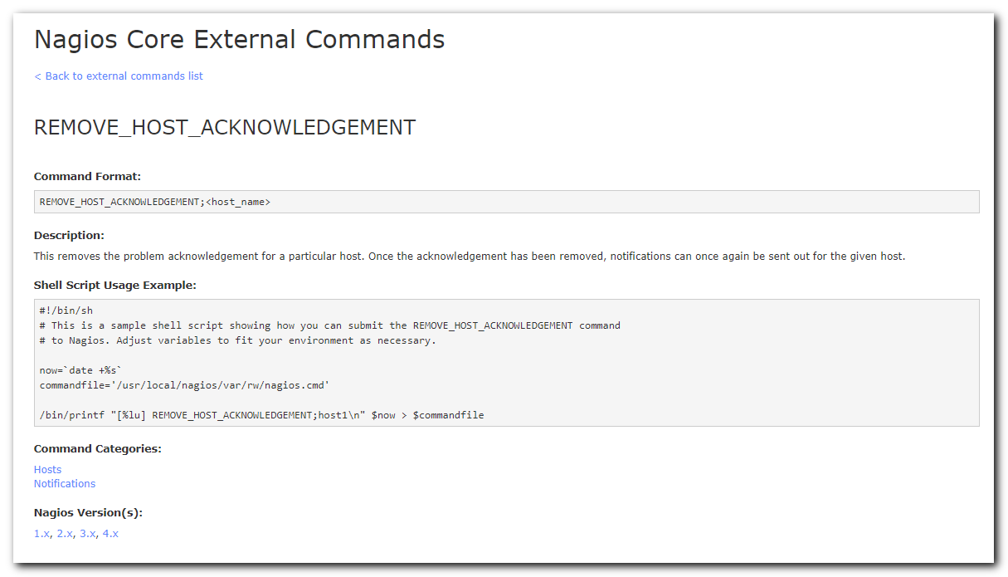

https://assets.nagios.com/downloads/nagioscore/docs/externalcmds/cmdinfo.php?command_id=117
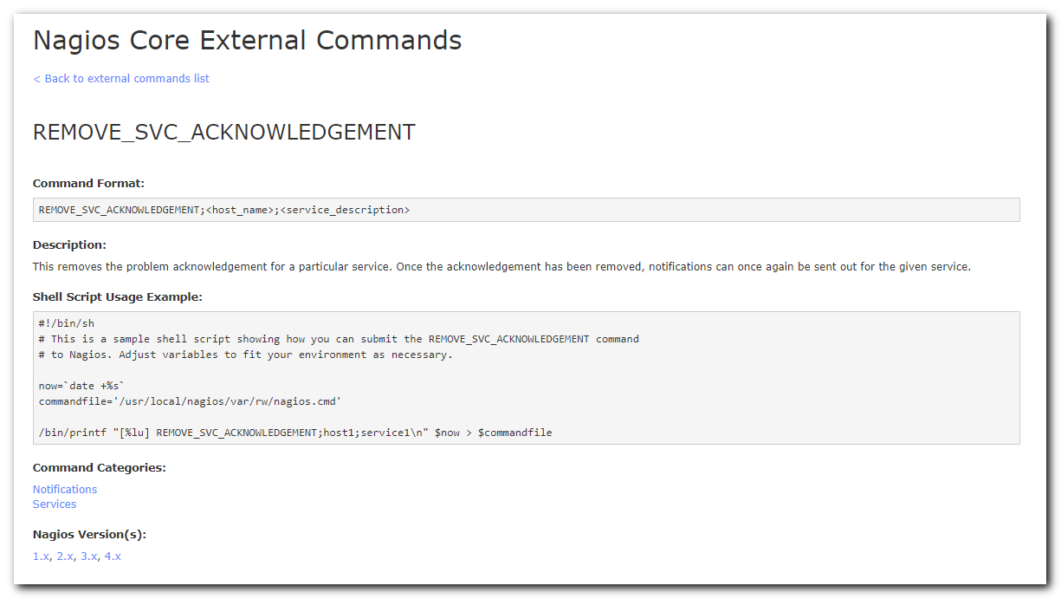

[root@vm-vol-nag4-prod nagios]# now=`date +%s` ; printf "[%lu] REMOVE_SVC_ACKNOWLEDGEMENT;host1;service1\n" $now
[1570544028] REMOVE_SVC_ACKNOWLEDGEMENT;host1;service1
[root@vm-vol-nag4-prod nagios]#

[root@vm-vol-nag4-prod nagios]# echo -e "[$(date +%s)] REMOVE_SVC_ACKNOWLEDGEMENT;host1;service1"
[1570545532] REMOVE_SVC_ACKNOWLEDGEMENT;host1;service1
[root@vm-vol-nag4-prod nagios]#

#
# К сожалению по типу комментария не удастся удалить acknowledge.
# Потому, что есть комментарии с типом acknowledge (когда-то они появились при выставлении acknowledge), но вот самого acknowledge уже нет.
#
[root@vm-vol-nag4-prod nagios]# echo -e "[$(date +%s)] REMOVE_SVC_ACKNOWLEDGEMENT;vm-esb-tst01;Check Updates" > /usr/local/nagios/var/rw/nagios.cmd

[root@vm-vol-nag4-prod ~]# less /var/log/nagios/nagios.log
...
[1570546062] EXTERNAL COMMAND: REMOVE_SVC_ACKNOWLEDGEMENT;vm-esb-tst01;Check Updates
...

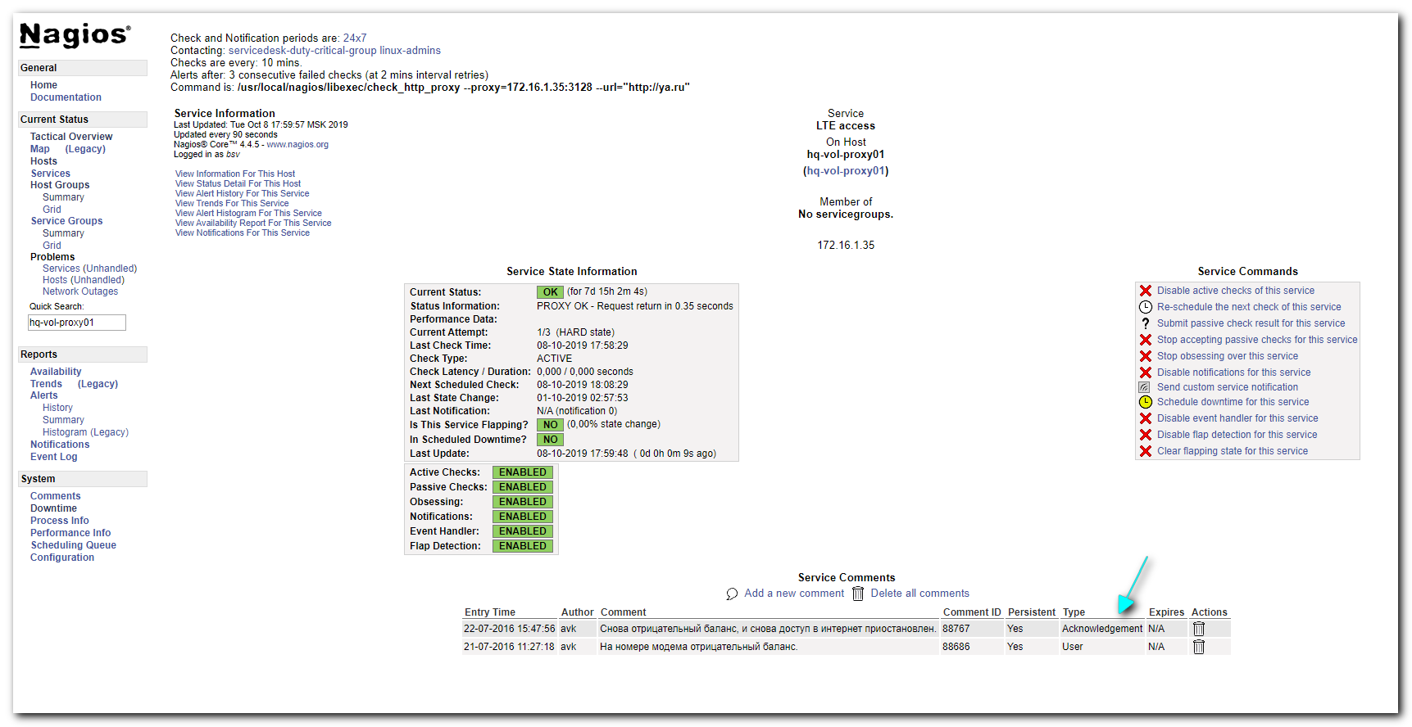

# И вот похоже нужно будет искать хосты и сервисы в состоянии acknowledge потом смотреть когда был сделан комментарий с типом acknowledge для них. И если давность больше 7 дней, то удалять acknowledge и все комментарии с типом acknowledge.
#

[root@vm-vol-nag4-prod nagios]# let days=7 ; let hours=$( expr ${days} \* 24 ) ; echo -e "GET services\nFilter: acknowledged = 1\nColumns: host_name service_description" | /usr/local/bin/unixcat /usr/local/nagios/var/rw/live
ds-asterisk10;HP System Health Application
ds-db31-prod1;Partition All local
ds-nice-db01;Drive D: Space
ekb-mvno-kvm05p;Server Health ilo5
m1-db31-dr;Partition All local
m1-gp-prod-sdw47;Server Health
m1-gp-prod-sdw54;Server Health
m1-hadoop-wk06t;HP System Health Application
m1-sql01;Service: SQL Server Analysis - MSSQLSERVER
vm-nice-wfm;Memory Usage
[root@vm-vol-nag4-prod nagios]#

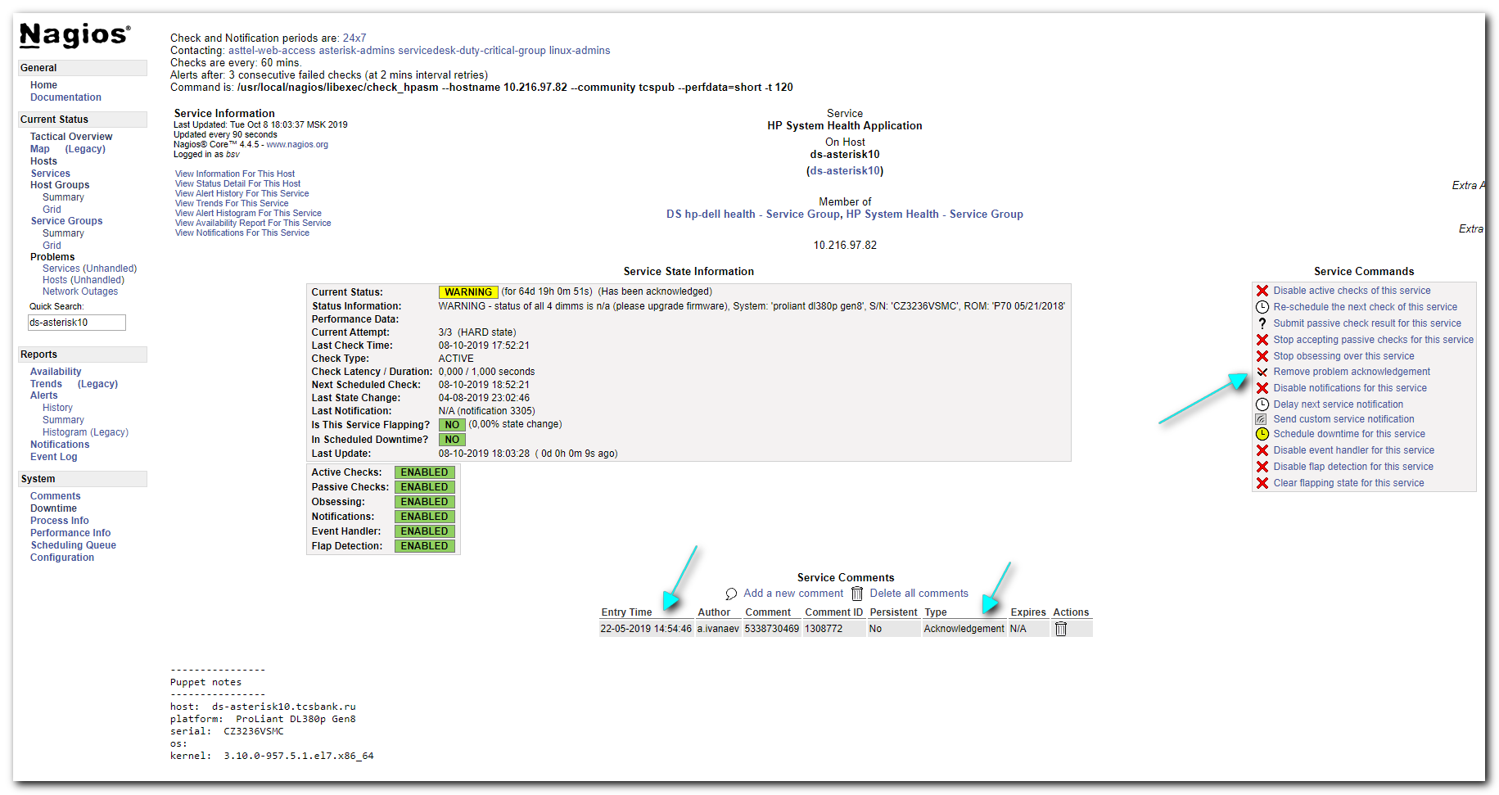

[root@vm-vol-nag4-prod nagios]# let days=1 ; let hours=$( expr ${days} \* 24 ) ; echo -e "GET comments\nFilter: host_name = ds-asterisk10\nFilter: service_description = HP System Health Application\nFilter: entry_type = 4\nFilter: entry_time <= $(expr $(date "+%s") - ${hours} \* 60 \* 60)\nColumns: entry_time comment host_name service_description" | /usr/local/bin/unixcat /usr/local/nagios/var/rw/live
1558526086;5338730469;ds-asterisk10;HP System Health Application
[root@vm-vol-nag4-prod nagios]#

#
# How to use Filter in livestatus commands.
#

https://checkmk.com/cms_livestatus.html
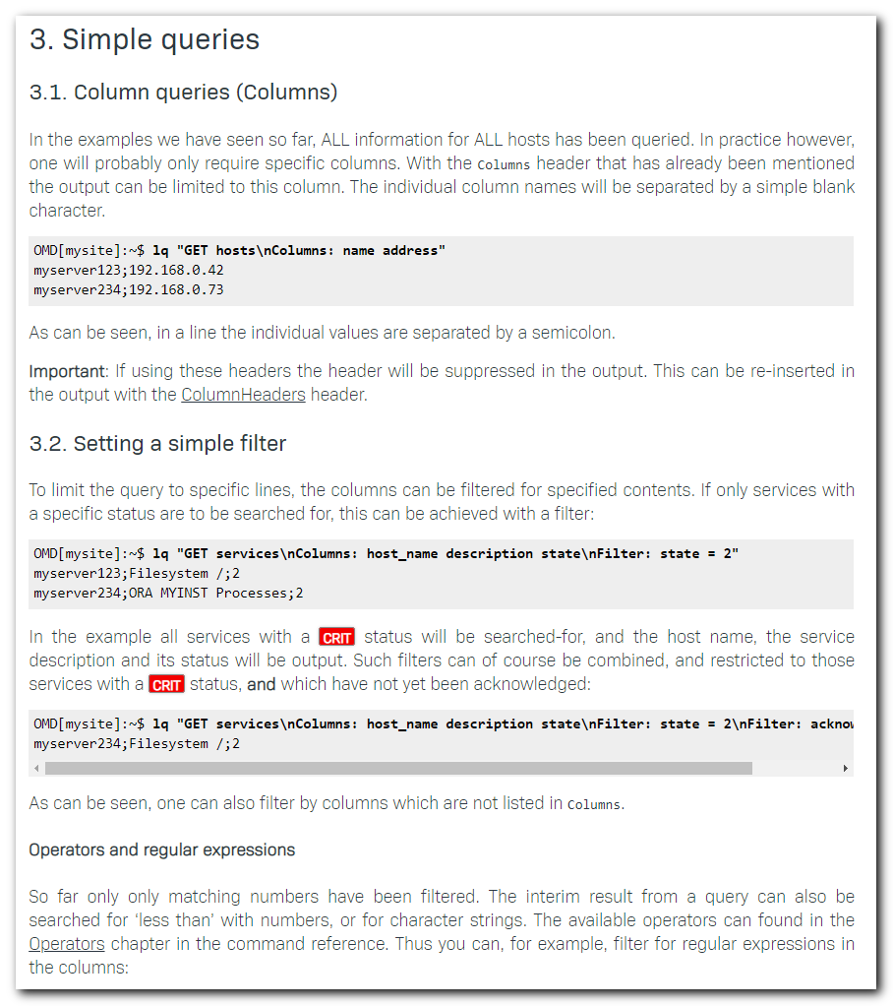
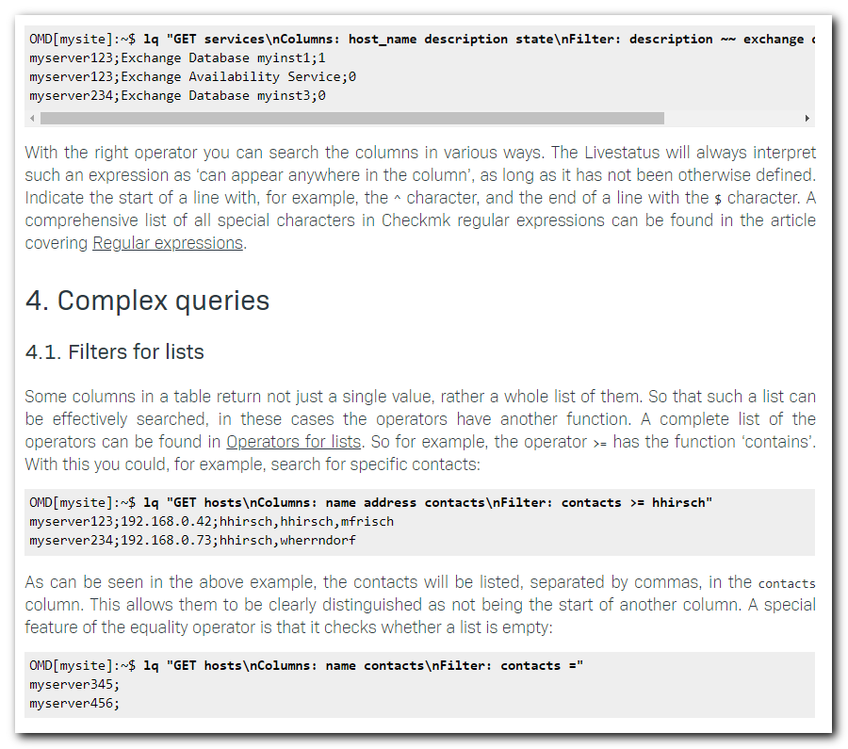
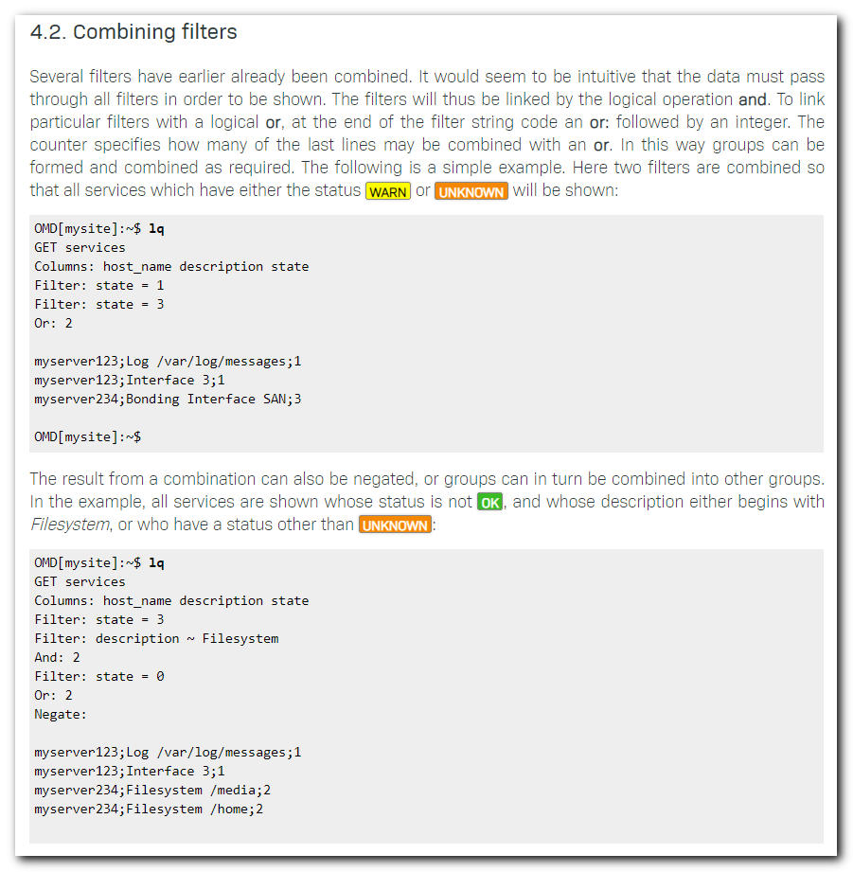

https://checkmk.com/cms_livestatus_references.html#operators
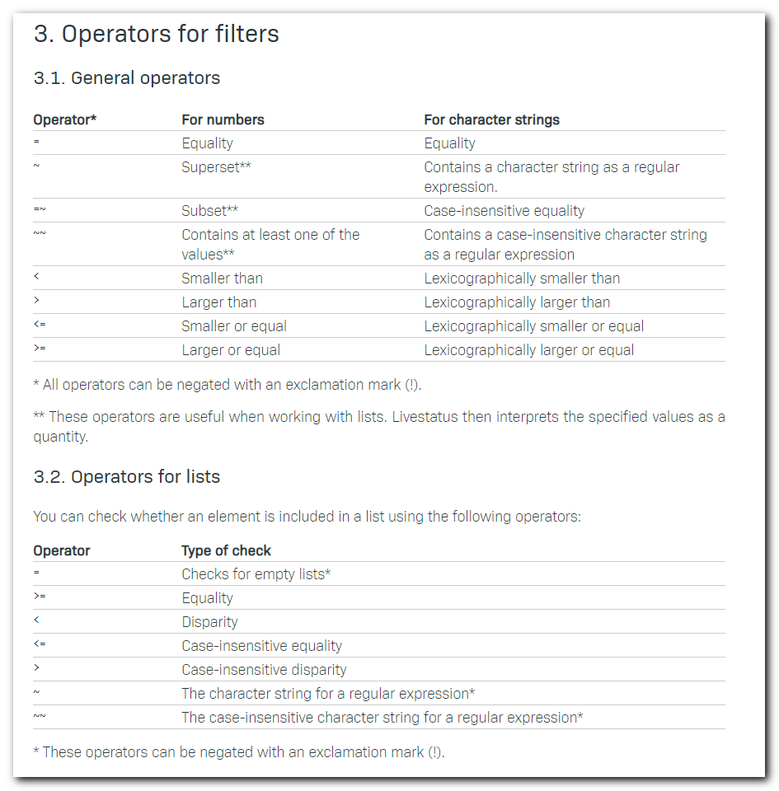

https://checkmk.com/cms_regexes.html#characters
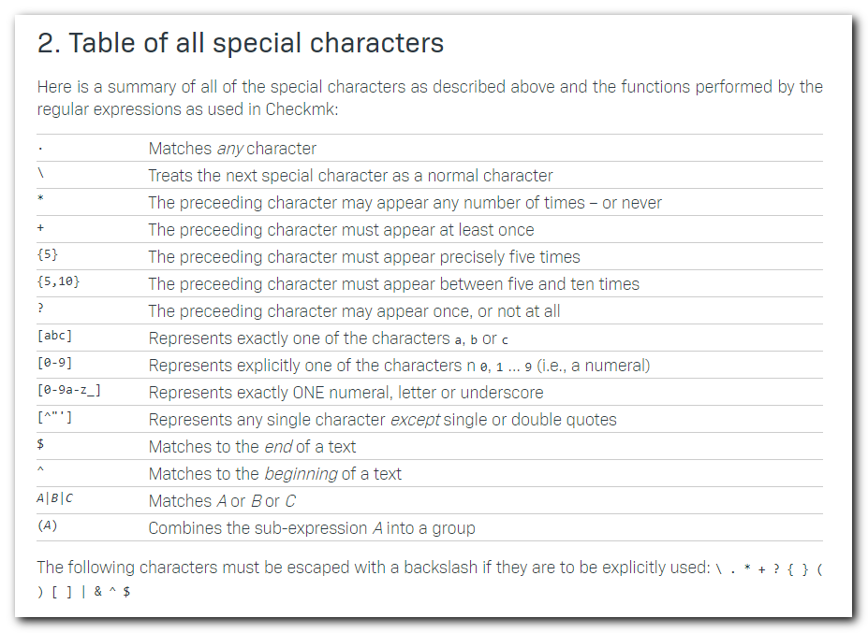

https://assets.nagios.com/downloads/nagioscore/docs/externalcmds/cmdinfo.php?command_id=15
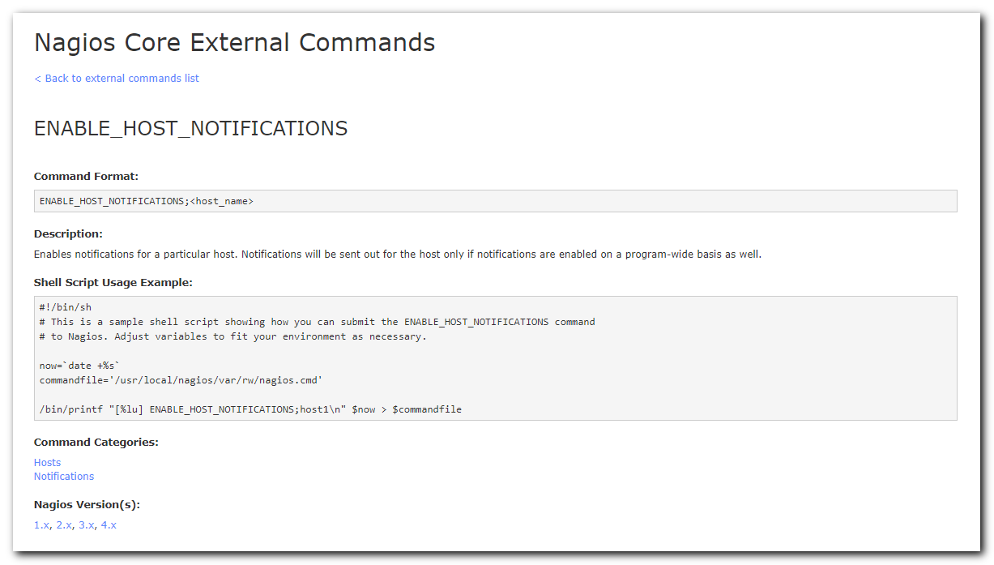

https://assets.nagios.com/downloads/nagioscore/docs/externalcmds/cmdinfo.php?command_id=11
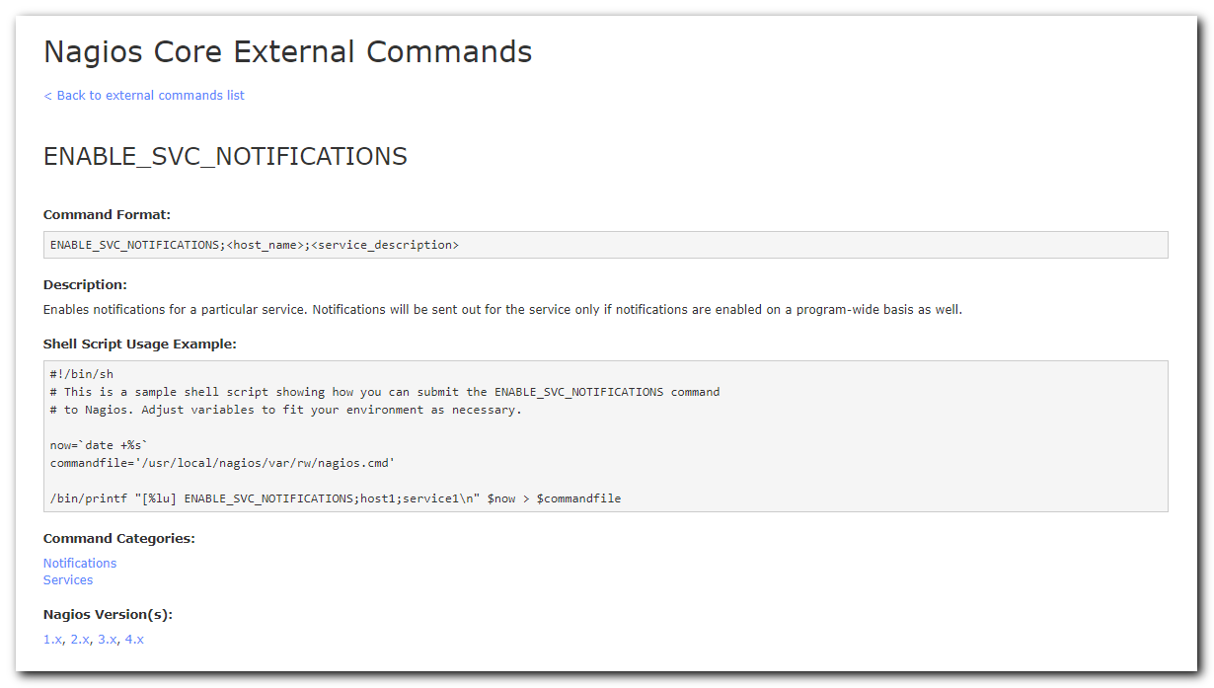

https://assets.nagios.com/downloads/nagioscore/docs/externalcmds/cmdinfo.php?command_id=16
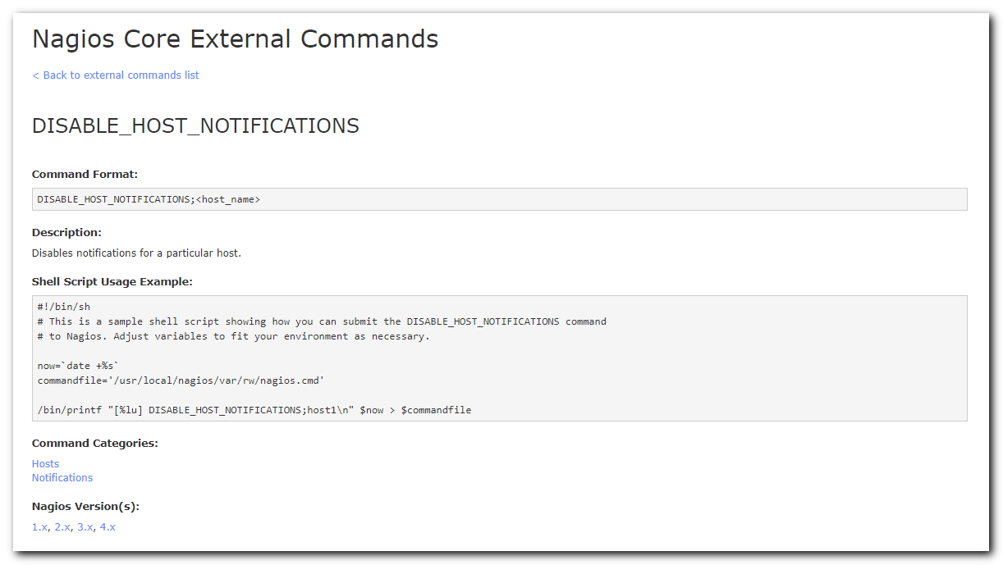

https://assets.nagios.com/downloads/nagioscore/docs/externalcmds/cmdinfo.php?command_id=12
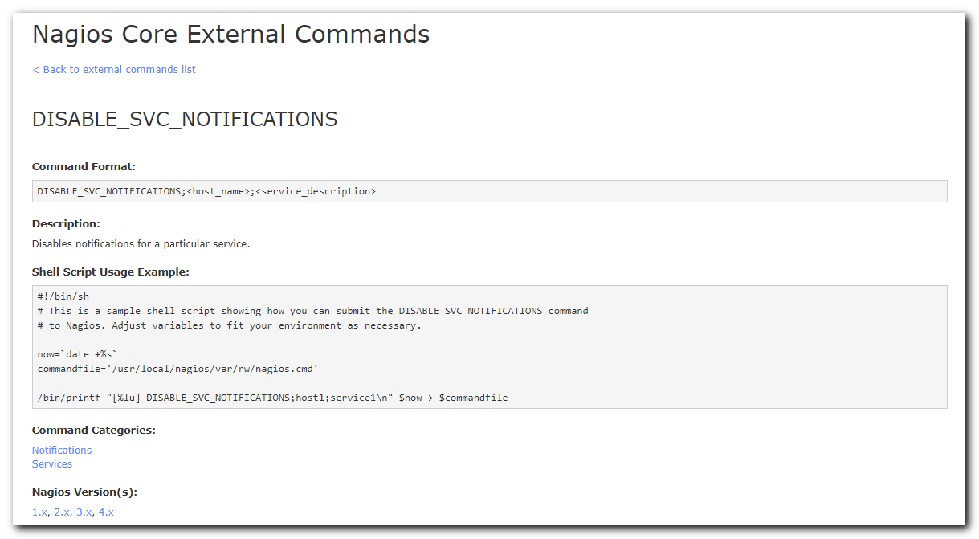

notification_via_nagios_livestatus_broker_module_services_with_notifications_manually_turned_off_and_older_than_several_days

email_notification_for_nagios_find_services_with_notifications_manually_turned_off_and_older_than_several_days.sh

[root@vm-vol-nag4-prod nagios]# time ./nagios_find_services_with_notifications_manually_turned_off_and_older_than_several_days.sh [524/4577]
Notifications disabled earlier 90 days. All found are stay.

Host: ds-bpm-prod-elastic-1
Service: Current Load
State: OK

Host: ds-bpm-prod-elastic-2
Service: Current Load
State: OK

Host: ds-db22-prod2
Service: Current Memory Load
State: WARNING

Host: ds-sw02
Service: Power Supply 8
State: OK

Host: m1-bpm-prod-elastic-3
Service: Current Load
State: OK

Host: m1-db22-dr
Service: Current Memory Load
State: WARNING

Host: m1-sql01
Service: Service: SQL Server Analysis - MSSQLSERVER
State: CRITICAL

Host: m1-ws-stat01p
Service: CPU Load
State: OK

Host: vm-mon-app01
Service: http vm-mon-app01 8805
State: CRITICAL

Host: vm-sasaml02t
Service: CPU Load
State: OK

Host: vm-tbl-desk01p
Service: CPU Load
State: OK

Notifications disabled 90 days ago or older. All found are cleaned.

Host: AT2-PDU-OF3-L
Service: humidity PERCENT
State: OK

...

Host: vm-ws-stat02p
Service: CPU Load
State: OK

real 6m22.306s
user 2m33.124s
sys 1m55.027s
You have mail in /var/spool/mail/root
[root@vm-vol-nag4-prod nagios]#

[root@vm-vol-nag4-prod nagios]# time ./email_notification_for_nagios_find_services_with_notifications_manually_turned_off_and_older_than_several_days.sh

real 4m49.860s
user 2m32.870s
sys 1m53.104s
[root@vm-vol-nag4-prod nagios]#

[root@vm-vol-nag4-prod nagios]# time ./email_notification_for_nagios_find_services_with_notifications_manually_turned_off_and_older_than_several_days.sh

real 0m15.960s
user 0m8.519s
sys 0m6.451s
[root@vm-vol-nag4-prod nagios]#

notification_via_nagios_livestatus_broker_module_hosts_with_notifications_manually_turned_off_and_older_than_several_days

[root@vm-vol-nag4-prod nagios]# ./nagios_find_hosts_with_notifications_manually_turned_off_and_older_than_several_days.sh
Notifications disabled earlier 90 days. All found are stay.

Host: m1-net-ilb08
State: UP

Notifications disabled 90 days ago or older. All found are cleaned.

Host: ds-net-ilb05
State: UP

Host: ds-tcrm-prod1-api-1
State: UP

Host: m1-ilb01-vl1900
State: UP

Host: m1-md-prod-rts01
State: UP

Host: vd-mgmt-dgu
State: UP
[root@vm-vol-nag4-prod nagios]#

